**Lab report no 5**



**Fall 2021**

# Computer Architecture and organization Lab

**Submitted By**

**Names Registration No**

# Muhammad Ali 19pwcse1801

Section: **A**

**Date**: 29,12,21

**Submitted to:**

**Dr Amaad khalil**

Department of Computer Systems Engineering

University of Engineering and Technology, Peshawar

**Task no 1: -**

In this task I user enter small alphabet and it will print capital alphabet of enter alphabet.

**Code: -**

.data

info: .ascii" Name:Muhammad Ali---- Reg.no:19pwcse1801"

msg: .asciiz"enter a small alphabet\n"

space: .asciiz"\ncapatital alphabet is \n"

.text

#for information name and registration number

li $v0 ,4

la $a0 ,info

syscall

#for integer

li $v0 ,4

la $a0 ,msg

syscall

#enter ascii

li $v0 ,12

syscall

move $t1,$v0

#space

li $v0 ,4

la $a0 ,space

syscall

sub $t0, $t1, 32

move $a0 ,$t0

li $v0 ,11

syscall

li $v0 ,10

syscall

**Register: -**

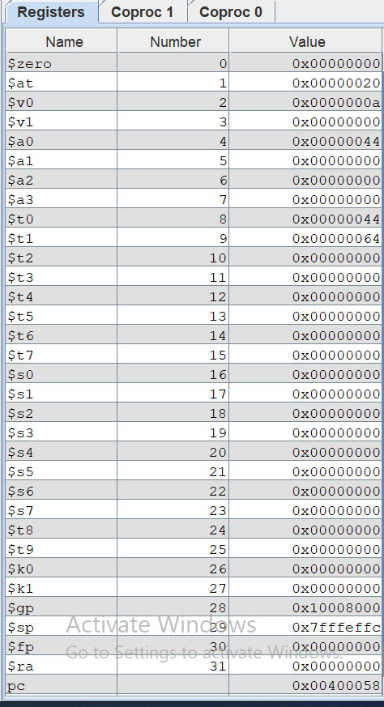

**Consul: -**

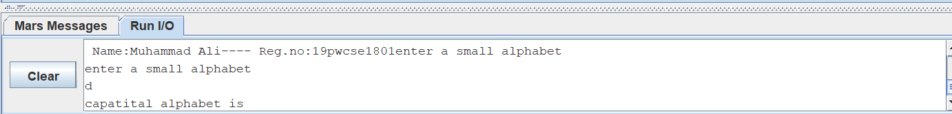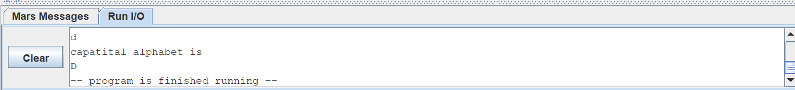

**Task no 2: -**

In this task user enter two number for some operational. Sign symbol is enter by user for specific operation with the help of ascii values.

**Code: -**

.data

info: .ascii" Name:Muhammad Ali---- Reg.no:19pwcse1801 \n"

msg: .asciiz"enter a number \n"

msg1: .asciiz"enter second number\n"

msg2: .asciiz"enter symbol for operation "

space: .asciiz" \n"

no1: .word 43

no2: .word 45

no3: .word 42

no4: .word 47

.text

lw $t3 ,no1

lw $t4 ,no2

lw $t5 ,no3

lw $t6 ,no4

#for information name and registration number

li $v0 ,4

la $a0 ,info

syscall

#for integer

li $v0 ,4

la $a0 ,msg

syscall

#enter ascii

li $v0 ,5

syscall

move $t0,$v0

#for integer

li $v0 ,4

la $a0 ,msg1

syscall

#enter ascii

li $v0 ,5

syscall

move $t1,$v0

#space

li $v0 ,4

la $a0 ,msg2

syscall

li $v0 ,12

syscall

move $t2,$v0

#for integer

li $v0 ,4

la $a0 ,space

syscall

beq $t2,$t3, labeladd

beq $t2,$t4, labelsub

beq $t2,$t5, labelmul

beq $t2,$t6, labeldiv

labeladd:

add $t3, $t0,$t1

move $a0,$t3

li $v0 ,1

syscall

b end

labelsub:

sub $t3, $t0,$t1

move $a0,$t3

li $v0 ,1

syscall

b end

labelmul:

mul $t3, $t0,$t1

move $a0,$t3

li $v0 ,1

syscall

b end

labeldiv:

div $t3, $t0,$t1

mfhi $t4

move $a0,$t4

li $v0 ,1

syscall

b end

end:

li $v0 ,10

syscall

**Register: -**

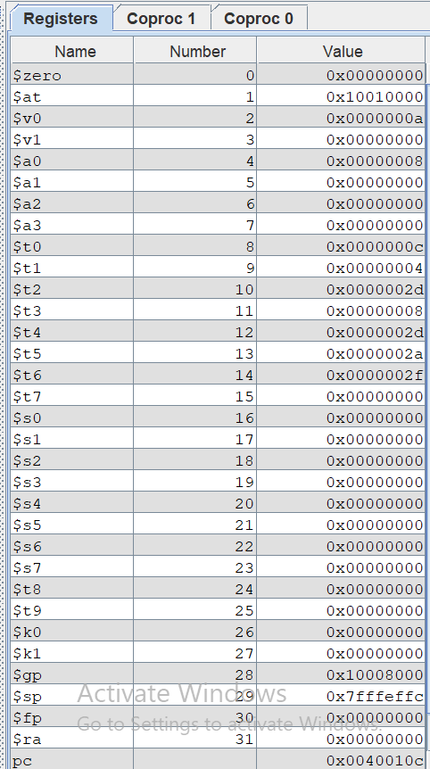

**Consul: -**

